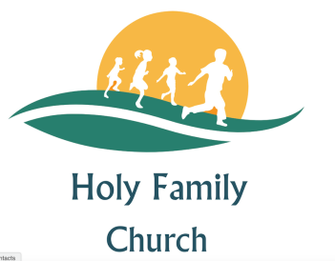
ANGLICAN, BAPTIST, METHODIST, MORAVIAN, UNITED REFORMED CHURCH
1 Cuddesdon Way, Blackbird Leys, Oxford OX4 6JH
HOLY FAMILY CHURCH
BLACKBIRD LEYS

Wedding and Banns Booking Form
Place Marriage is to be held__________________________
Date_____________________________________________
Name of Minister___________________________________

Groom’s Full Name_________________________________________________
Current Address___________________________________________________
Postcode___________________ Phone Number_________________________
Email______________________ Date of Birth___________________________
Occupation or profession____________________________________________
Have you been married/ civil partnered previously Yes/No
Are you a foreign national Yes/No Photo I:D Checked Yes/No

Bride’s Full Name_________________________________________________
Current Address___________________________________________________
Postcode___________________ Phone Number_________________________
Email________________________ Date of Birth________________________
Occupation or profession____________________________________________
Have you been married/ in a CP previously Yes/No Are you related Yes/No
Are you a foreign national Yes/No Photo I:D Checked Yes/No

Groom’s Fathers full name__________________________________________
Occupation or Profession____________________________________________
Bride’s Fathers full name____________________________________________
Occupation or Profession____________________________________________

